Practical 1
Aim : Basic commands of linux and hadoop
Commands for Linux

- sudo : Used to perform tasks that requires root permissions.
- pwd : It shows the present working directory.
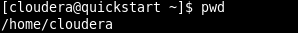

- cd : It is use to come back in the root directory.

- ls : It list down all the directories and folders present.

- cat : Displays the content of the file.
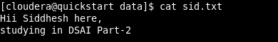

- cp : Copy one file from current directory to another directory.
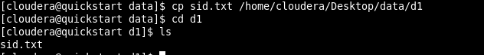

- mv : Used to move and rename files and directories.
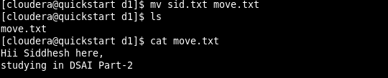

- mkdir : Creates a new directory.
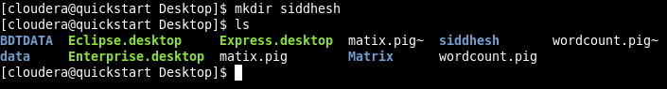
- rmdir : Deletes the directory.
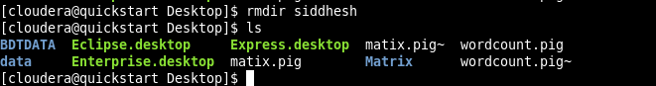

- rm : Removes/ Deletes the file from a directory.
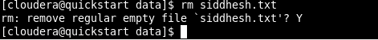

- touch : Creates an empty file.
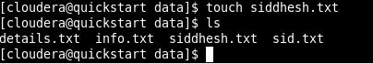

- stat : Detail view of the file.
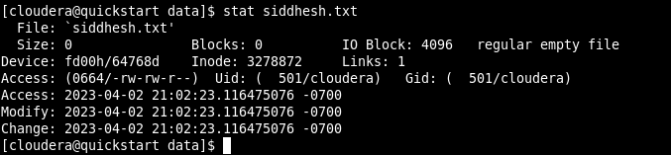

- vi : Creates and open the file.
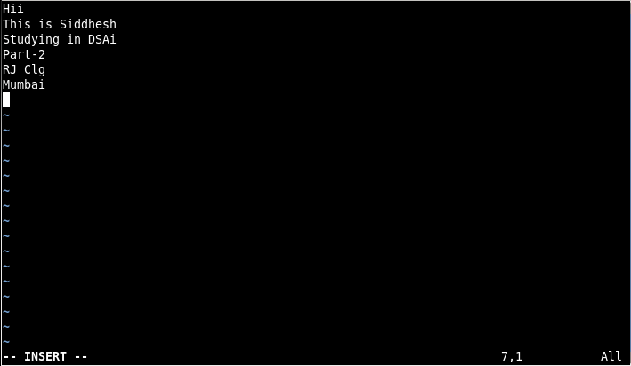
- head : Displays the first 10 lines of a text file.
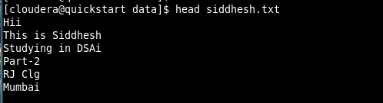
- tail : Displays the last 10 lines of a text file.
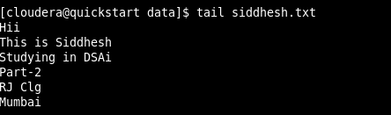

Commands for Hadoop

- hadoop version : Gives the version of the hadoop.
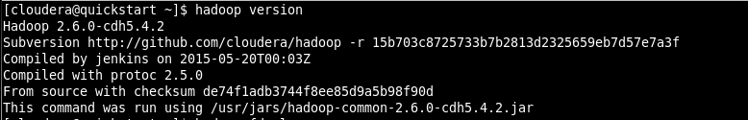

- ls : List down all the files in hadoop.
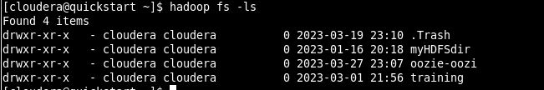

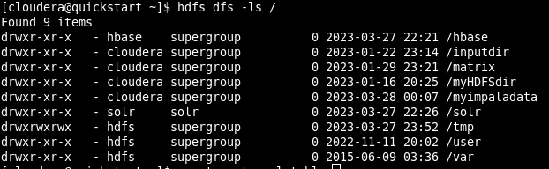

- mkdir : Create a directory.
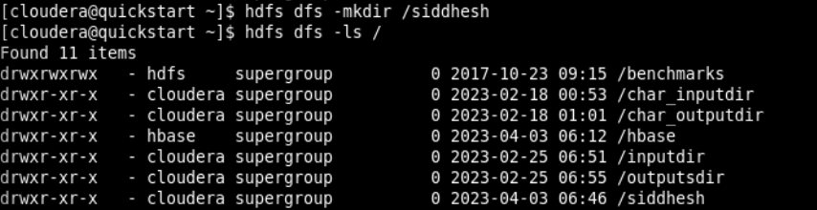

- touchz : Creates a new file.

- put : Copy files/folders from local file system to HDFS.

- cat : Prints the file contents.
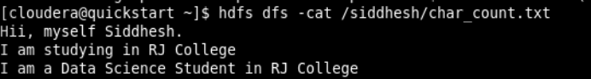

- cp : Use to copy files within HDFS
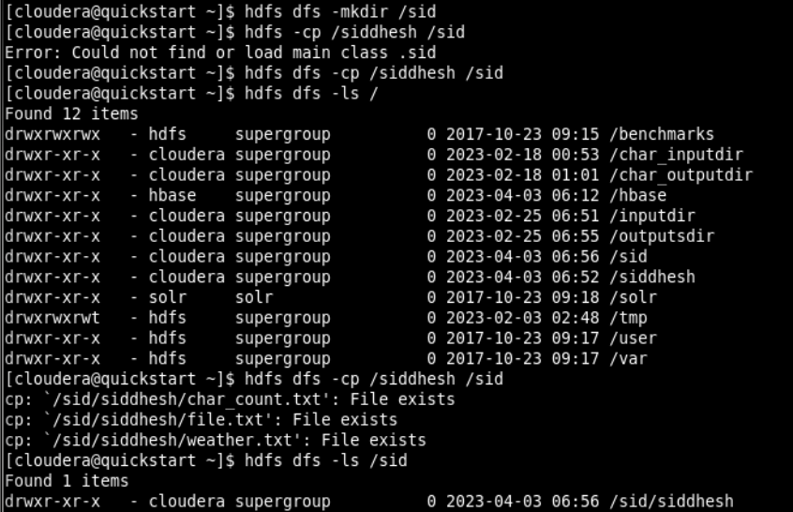

- rm : Deletes a file from the HDFS.
